Hello friend,

I have checked your Paper#2. However, it is not what the prompt asked. You have to do another TOTAL REVISION. MOST OF YOUR PARAGRAPH WAS SUMMARY. PLEASE DO NOT SUMMARIZE WHAT HAPPENS IN THE STORY INSTEAD TELL YOUR ARGUMENTS WHAT YOU THINK ABOUT HOW THE SIGNIFICANCE OF VIETNAM WAR HAS SHAPED OR IMPACTED THE HISTORICAL EXPERIENCES OF VIETNAMESE. THEN, YOU SUPPORT WITH THE EVIDENCE FROM THE READING. (NOT SUMMARIZING THE READING)

This professor’s feedback still applies for the Paper#2 because your paper’s issues as the same as your past SWA’s issues:
“Your paper seems to focus a lot on summarizing details, mainly those of the Flora Belle Jan reading. You don’t get to the argument until the end of your first page and into your second page. Your first paragraph goes right into Flora Belle Jan, but does not establish your argument for the remainder of the paper.

If I were you, I would focus on revising to have less description of examples and more analysis. Organize the paper so that the reader knows exactly what your argument is at the very beginning of the paper, within the first paragraph. Do not organize your paper according to the readings you are using, but rather by the larger themes of your argument”

The things that you do wrong:

- Like the SWA#2, you do not need to make three sub-sections: Thesis, Argument, and Conclusion. Paper#2’s first paragraph, “at the very beginning of the paper,” wants you to make a thesis that is the central of the paper, so your audience knows the points you will deliver. Again it is not a summary, but your analysis/ argument toward the prompt. It supposed to be 4-7 sentences and not that long. Paper#2 is a just a longer version for the SWA#2, but the concept on how you do it is the same thing where you give your analysis toward the prompt and not summary the reading. First paragraph purposes. The first paragraph aims to tell the main theme of arguments that you will deliver for your whole paper, so your reader knows what will happen before reading the whole paper.

- Then, for the paragraph 2 until the end, the first sentence, you must begin the paragraph with a strong topic sentence. EACH PARAGRAPH SHOULD ONLY EXPLORE ONE POINT. Again, each paragraph consists of a clear topic sentence, your reason, and backed up with at least ONE ASA 001 COURSEPACK READING ASSIGNED BETWEEN WEEK 5 TO WEEK 10. THE USE OF ANY EXAMPLE OR EVIDENCE OUTSIDE FROM THE READING IS NOT PERMISSIBLE. I do not know how do you find this source: Miguel, Edward, and Gerard Roland then Pholsena, Vatthana, then Moyar, Mark. Triumph Forsaken. It must be outside of the COURSEPACK READING. Please use the source from John M Liu and Lucie Chang instead of Suchen Chang because my professor always mention those name. Please do not see the example of student’s work about WW2 that I gave you at first.

- Paper#2 is just the same thing as SWA#2. The reading purpose’s just to support your argument by telling the evidence. Please do not need to summarize the reading or telling what happens in the reading. Instead, you suppose to give analysis or argument about the prompt and show that the reading also supports your argument, which you did a good job in the SWA#2. This is graded on how you able to convince/ persuade your readers about your analysis toward the prompt. “Do not organize your paper according to the readings you are using, but rather by the larger themes of your argument.”

- You always summarize the reading. The reading purpose’s just to support your argument by telling the evidence. Please do not need to summarize the reading or telling what happens in the reading. Instead, you suppose to give analysis or argument about the prompt and show that the reading also supports your argument. This is graded on how you able to convince/ persuade your arguments to readers about your analysis toward the prompt. This is what the professor called “analysis.”- read the prompt.

- Each paragraph supposes to be in 4-7 sentences, a little longer than SWA#2, that begins with your strong topic sentences, your argument about it, and show the reading which reading supports your argument. You do not need to explain any details in the reading like you summary the reading OR what happens in the reading. EACH PARAGRAPH SHOULD ONLY EXPLORE ONE POINT. Therefore, do not make too many sentences because you will be delivering more than ONE SPECIFIC POINT.

- THINK OF YOUR ESSAY WHICH YOU SEEK TO PERSUADE OR CONVINCE YOUR READER BASED ON YOUR PERSPECTIVE. You have to remember that this paper aims to persuade readers to think differently based on your own argument or perspective on the prompt. Not summarize. You have to emphasize what do you think about it more.

- I do not know why you only discuss the significance of the Vietnam War in the economic aspect only. You can talk about Social and other event than that, so you have more ideas about what to write. (maximum words: 1200 words). Also, your recent work was way more than the maximum (1600 words)

- Your total evidence must drawn from at least THREE DIFFERENT READINGS FROM COURSEPACK READING, which I think you have followed on this one. For the formatting, do not write “ibid”, but you do a great job in doing the insert footnote.

PLEASE READ THE PROMPT CAREFULLY, SO YOU DO NOT NEED TO DO THE TOTAL REVISION OVER AND OVER AGAIN. Can you revise them in less than 24 hours, so I can check it again? I will release the bonus for the SWA2. I love the way you did my SWA2; it was on point and based on what the prompt asks.

Please read:

THE PAPER IS GRADED ON HOW YOU UNDERSTAND THE MATERIAL’S CONCEPT TO CONVINCE YOUR PERSPECTIVE TO THE READERS BASED ON THE PROMPT. MY PROFESSOR WANTS TO KNOW WHETHER YOU HAVE COMPREHEND THE MATERIALS’S CONCEPTS OR NOT AND HE GRADED IT BASED ON THAT WAY. IT IS NOT GRADED BASED HOW WELL YOU DO THE SUMMARY; IT IS NOT WHAT THE PROMPT ASKS. THEREFORE, THERE IS NO CORRECT OR WRONG ANSWER. YOU HAVE TO BE MORE CRITICAL IN DOING THIS. THANK YOU!

For the illustration, so you know the concept of this paper:

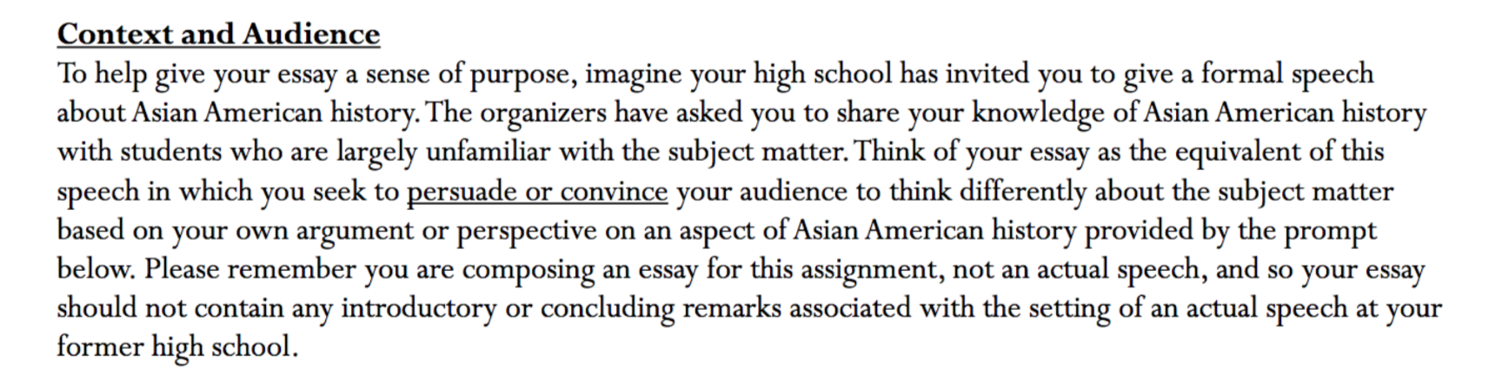

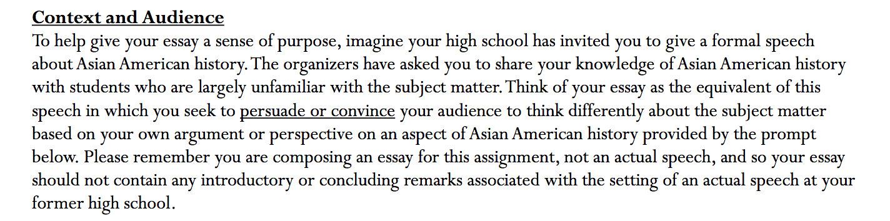
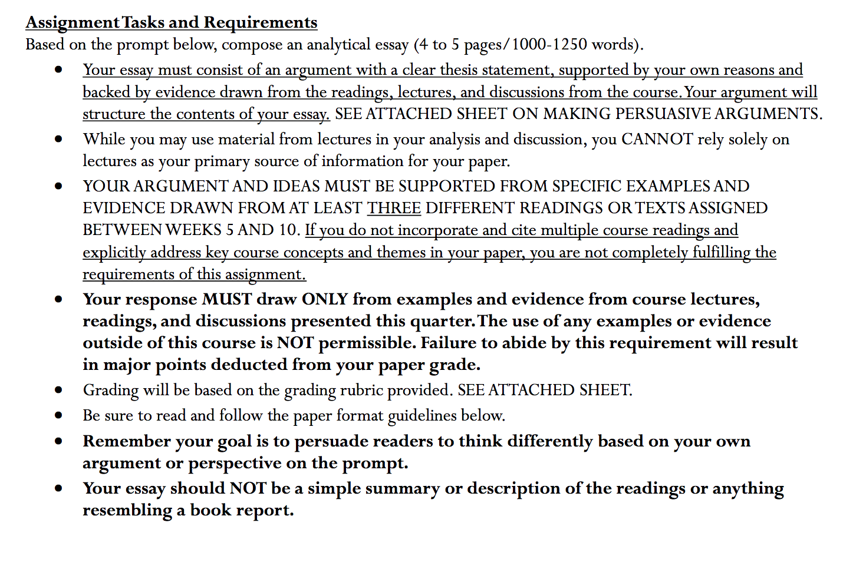
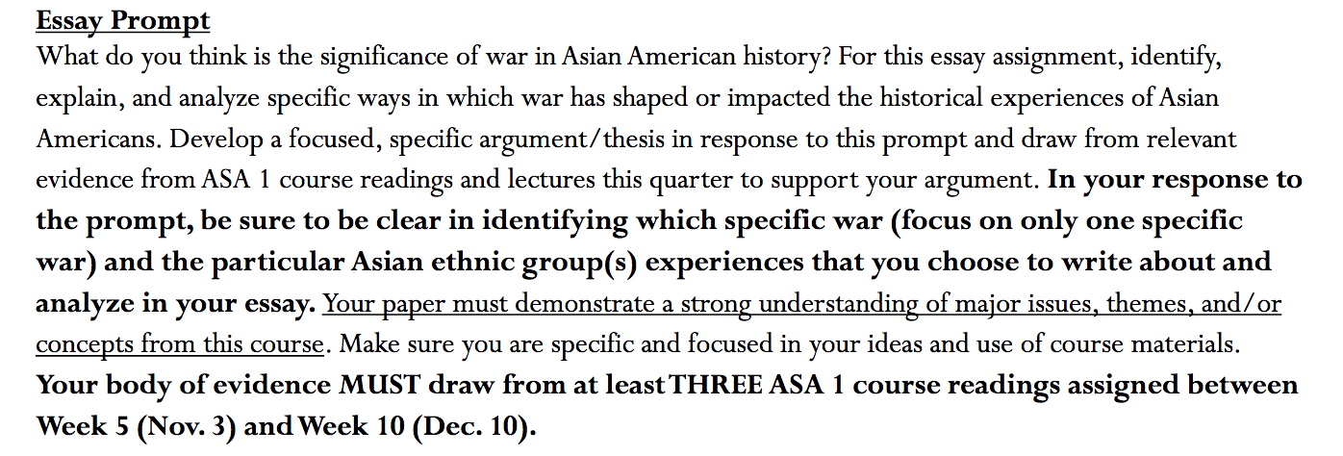

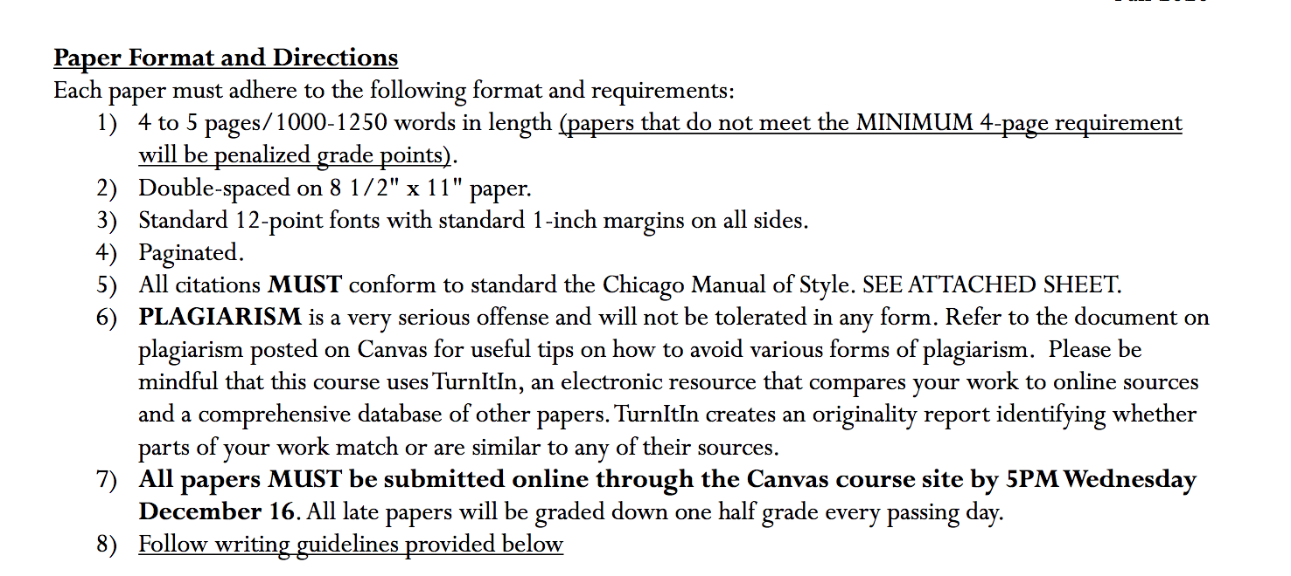

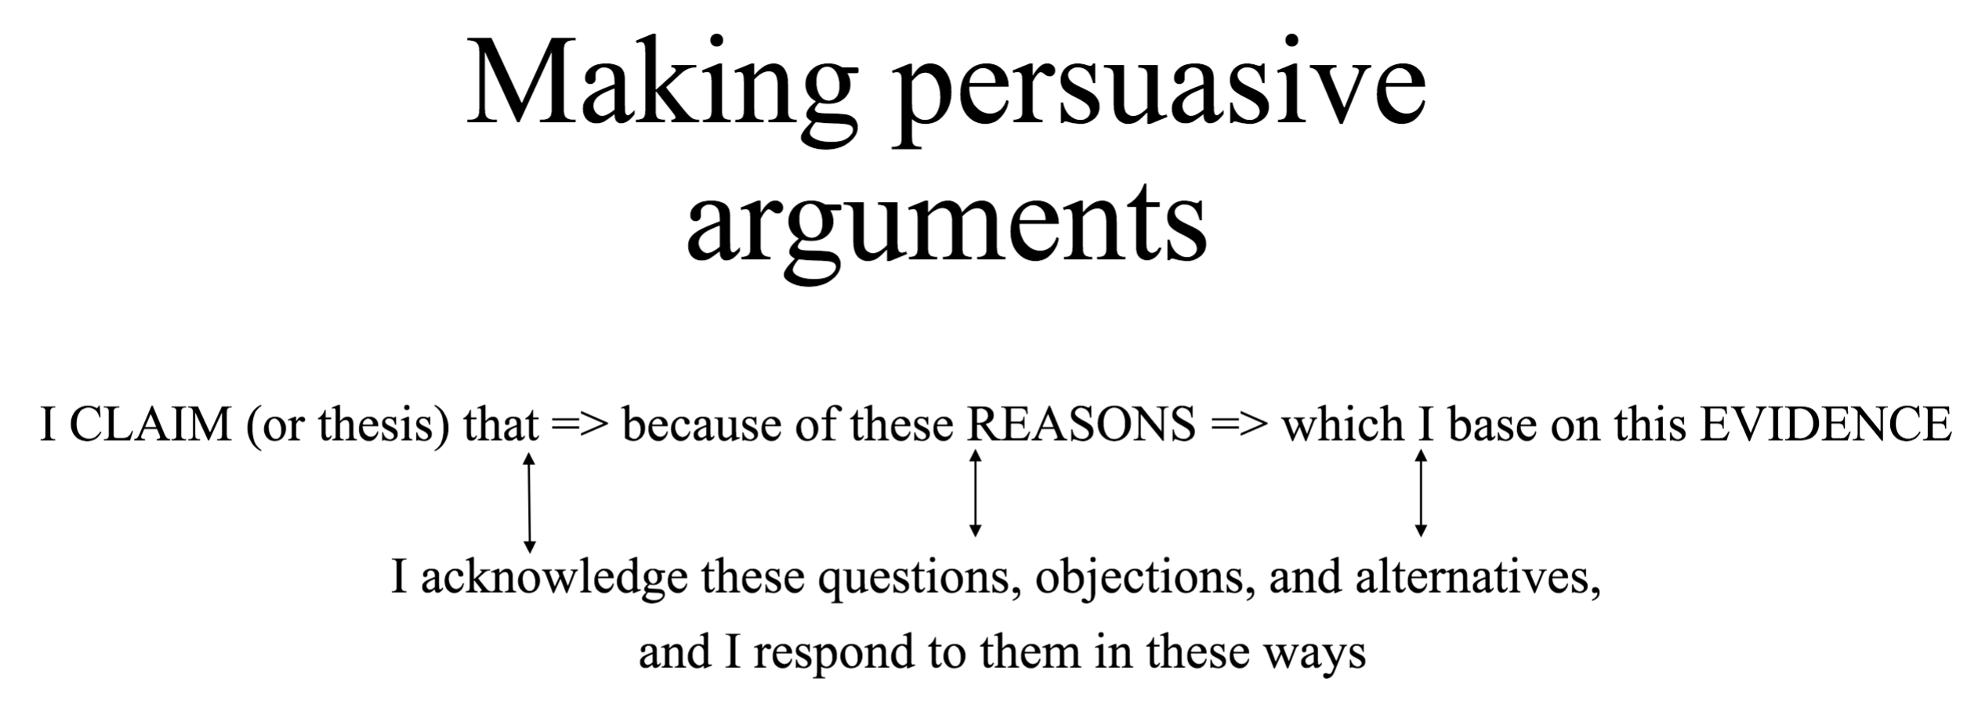

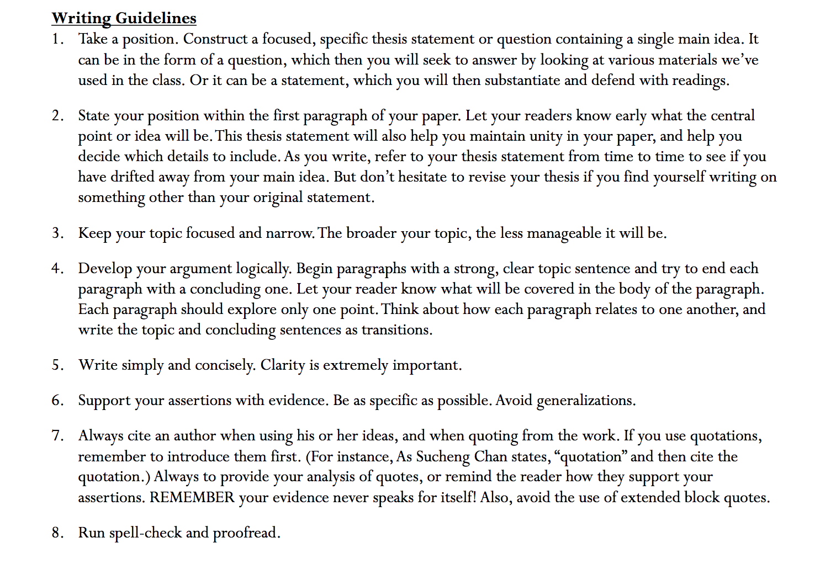

Here are points that you must read

To make it clear,

For point 1 and 7, please read it because the instruction is clear already.
For point 2, it says that for your first paragraph, please make a thesis that is the central of the paper, so your audience knows the points you will deliver. Again it is not a summary, but your analysis/ argument toward the prompt.
For point 4, as I tell you that please begin the paragraph with a clear topic sentence. EACH PARAGRAPH SHOULD ONLY EXPLORE ONE POINT. Again, each paragraph consists of a clear topic sentence, your reason, and backed up with at least one piece of evidence from the reading. The reading purpose’s just to support your argument by telling the evidence. Please do not need to summarize the reading or telling what happens in the reading. Instead, you suppose to give analysis or argument about the prompt and show that the reading also supports your argument. This is graded on how you able to convince/ persuade your readers about your analysis toward the prompt.

Your body of evidence must draw from at least THREE course reading assigned below!

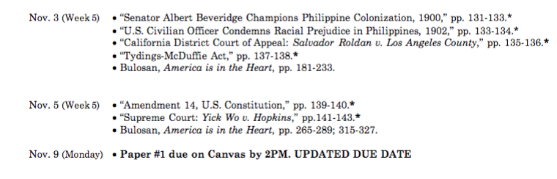

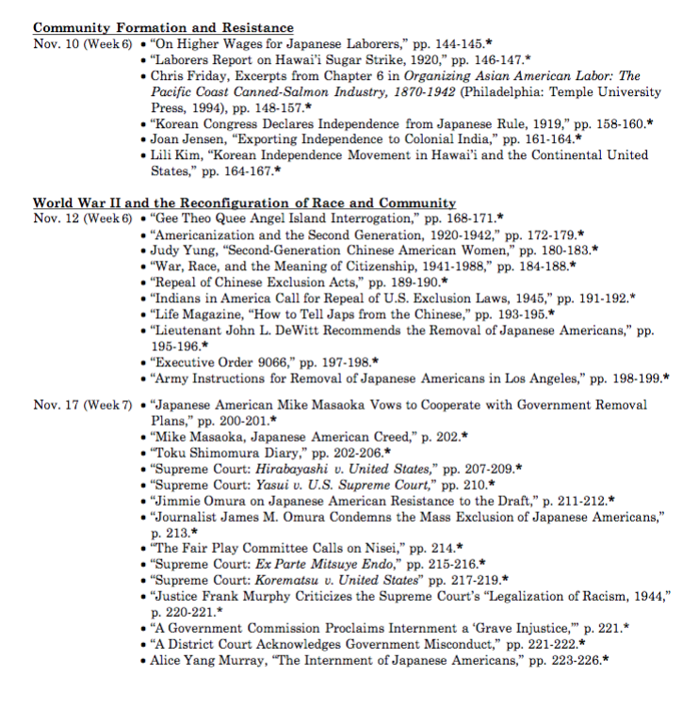

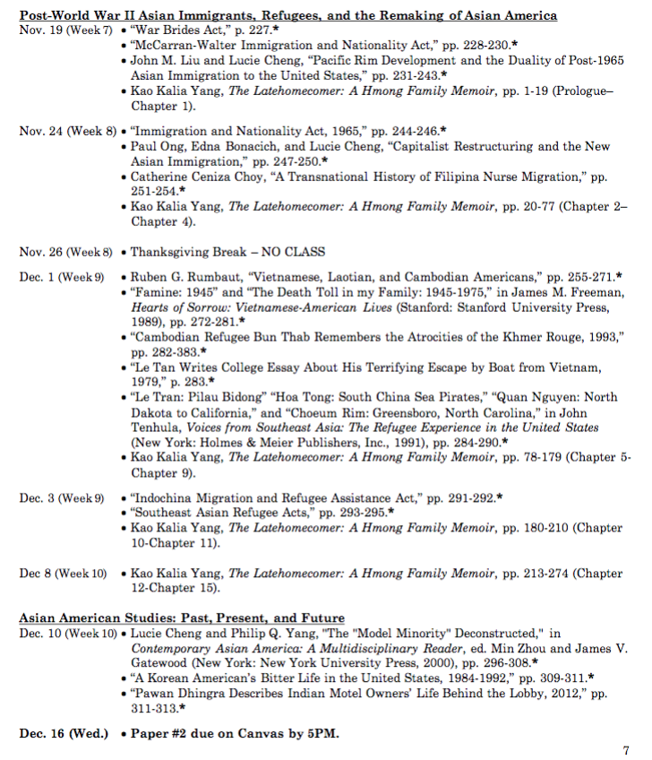

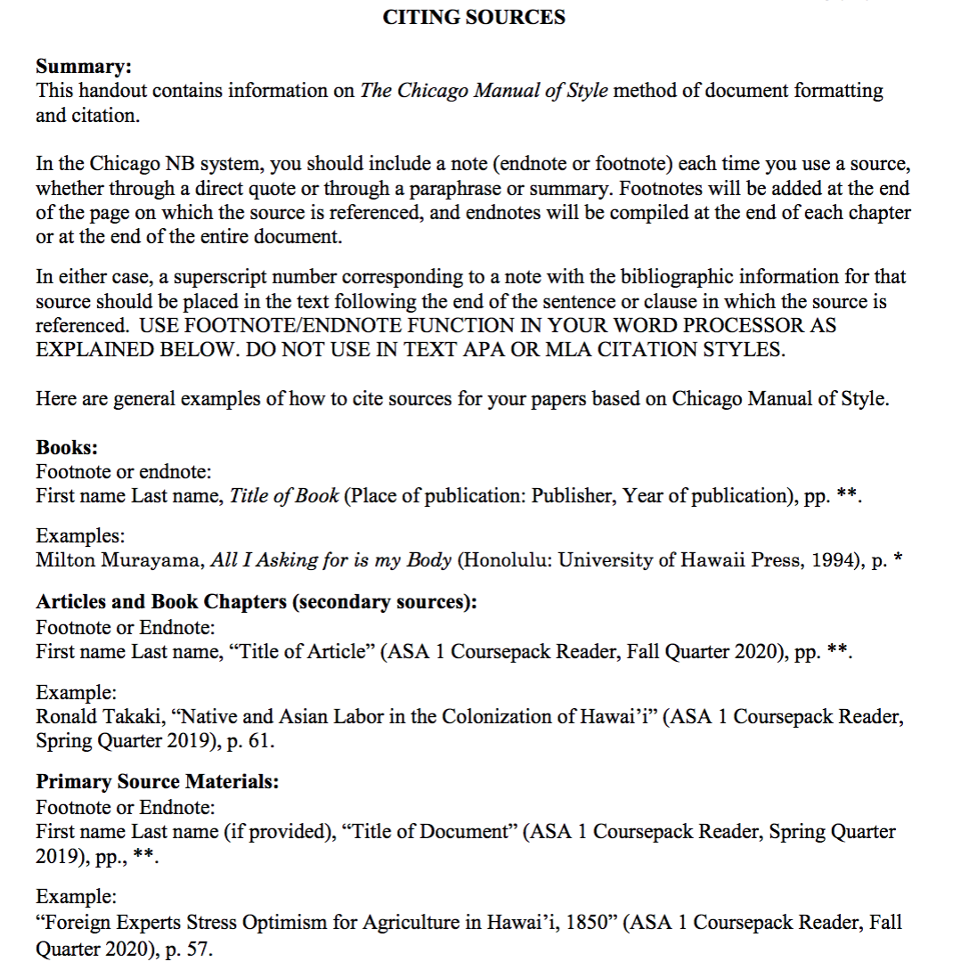

How to Access

Please see this link for the prompt and instruction!
https://canvas.ucdavis.edu/courses/511303
Then
UCD Login, which is the left one

Then
Username: sfelix
Password: GBumiPermai@F4/2

Then
See ASA 1 Paper #2 Prompt Essay Assignment.pdf in the bottom of the page

